Computer Networks
Campus Network Design
1-Network topology:

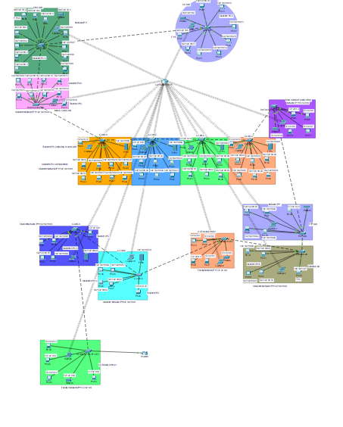

2-Hostnames changed of each switch in each lab.
Some screenshots and command:
enable
configure terminal
hostname CS-LAB
hostname Data-Science-Faculty-Office
hostname GBS-Lab
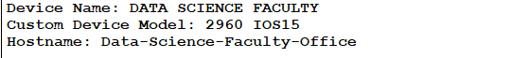
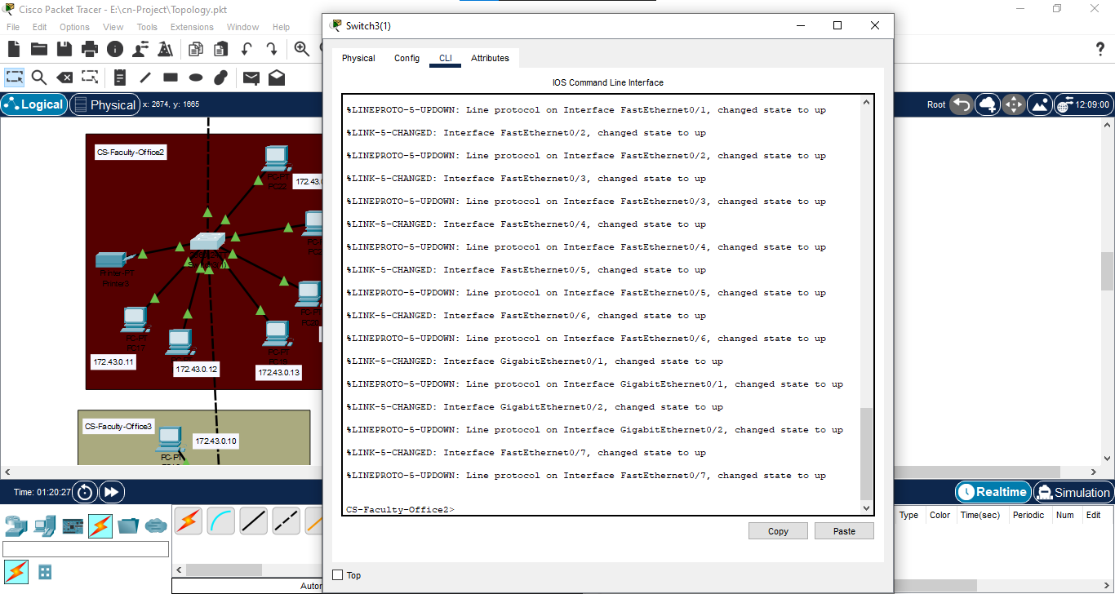

3- Mode changed to trunk:
Repeated for each lab’s switch:
Commands for this:
enable
configure terminal
interface gigabitEthernet 0/1
switchport mode trunk
no shutdown
exit
interface gigabitEthernet 0/2
switchport mode trunk
no shutdown
exit

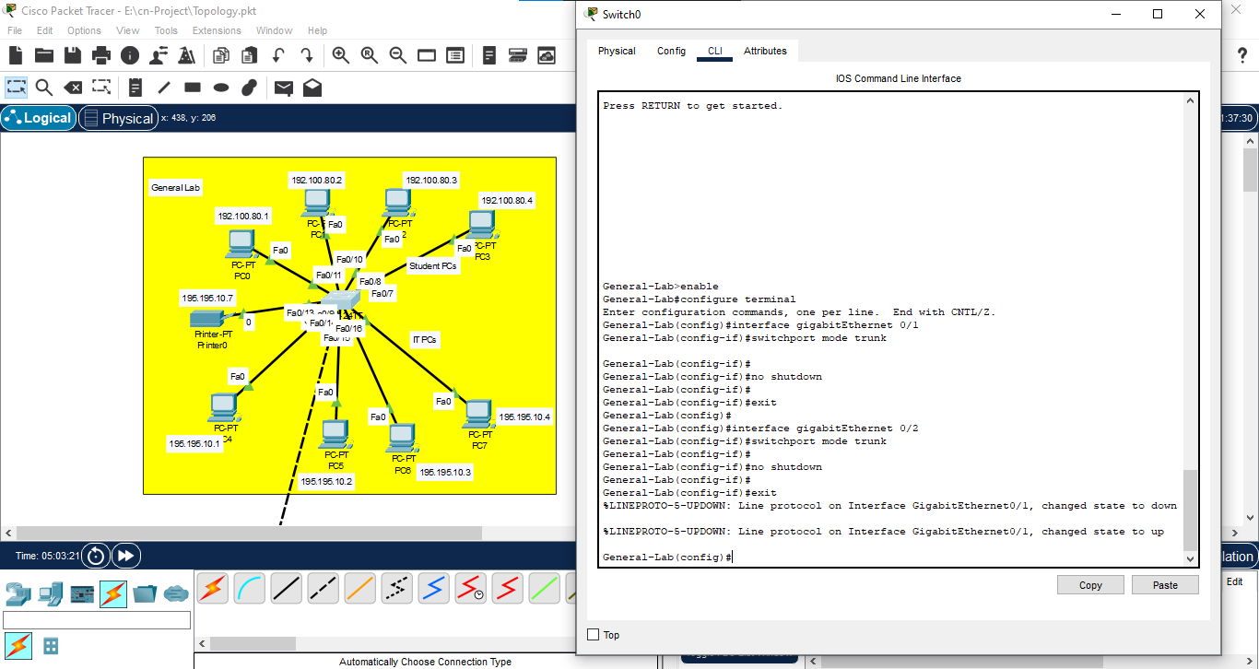

4- V-LAN Configuration:
Repeated for each lab.
enable
configure terminal
- vlan 10
name faculty
interface range fastethernet 0/1-6
switchport mode access
switchport access vlan 10
- vlan 20
name students
interface range fastethernet 0/7-12
switchport mode access
switchport access vlan 20
- vlan 30
name IT
interface range fastethernet 0/13-18
switchport mode access
switchport access vlan 30
exit
exit
show vlan
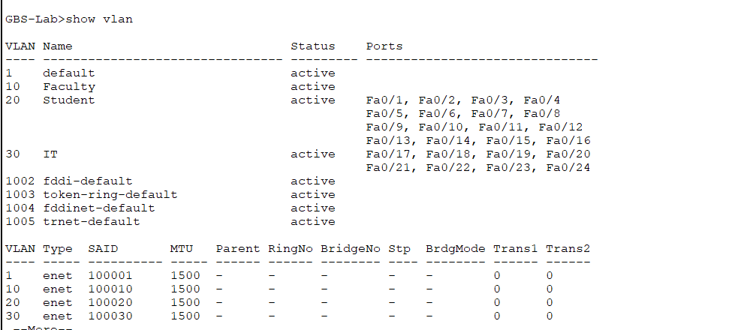
5-Inter-Vlan Routing:
Commands:
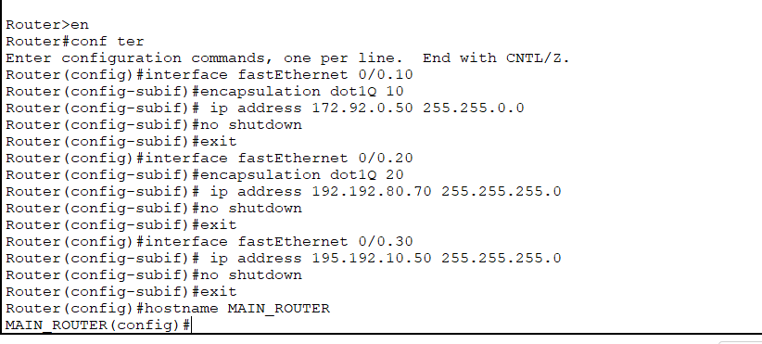
Show:
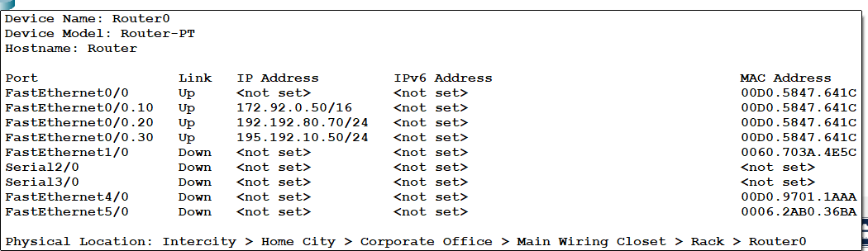

6- IP addressing:
Repeated for each topology accordingly, assigned given network ip’s and replaced two digits with my Roll No.
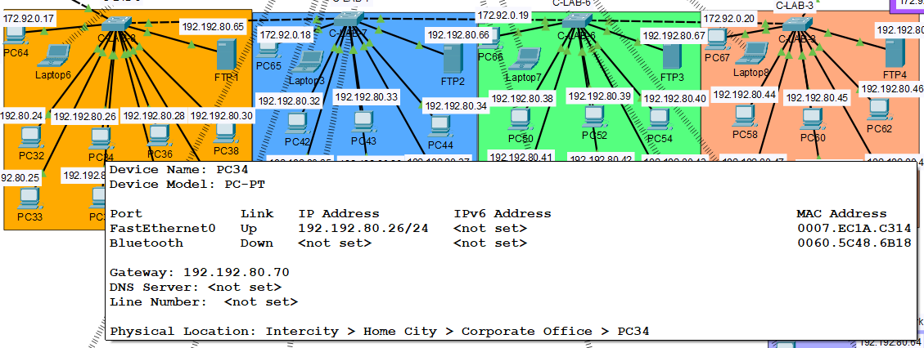
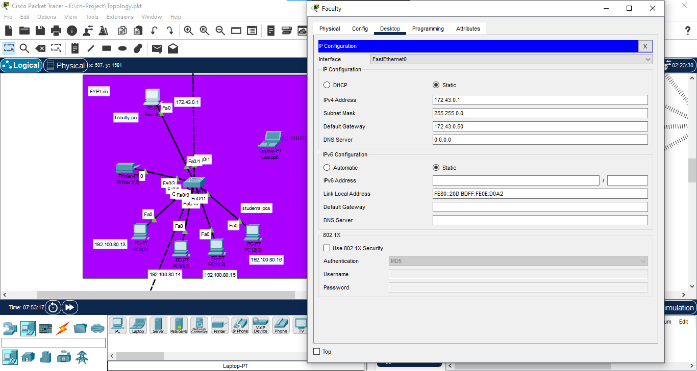

7- Printers:
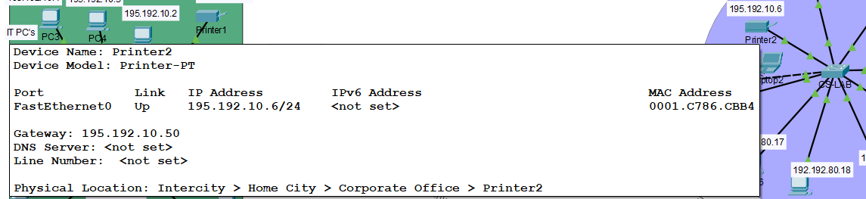

8-FTP server configuration:
Step 1: Users created—teacher and student with my name:
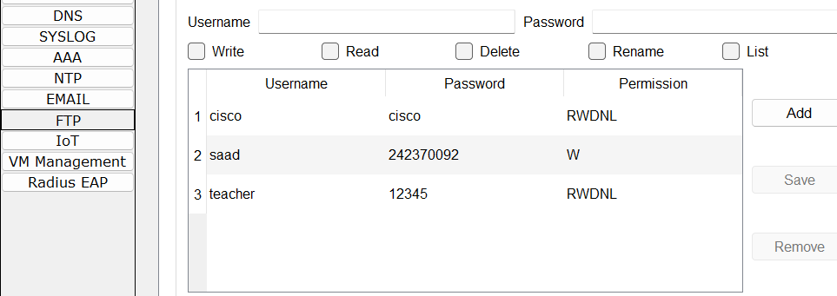
Step 2: configuration through CMD:
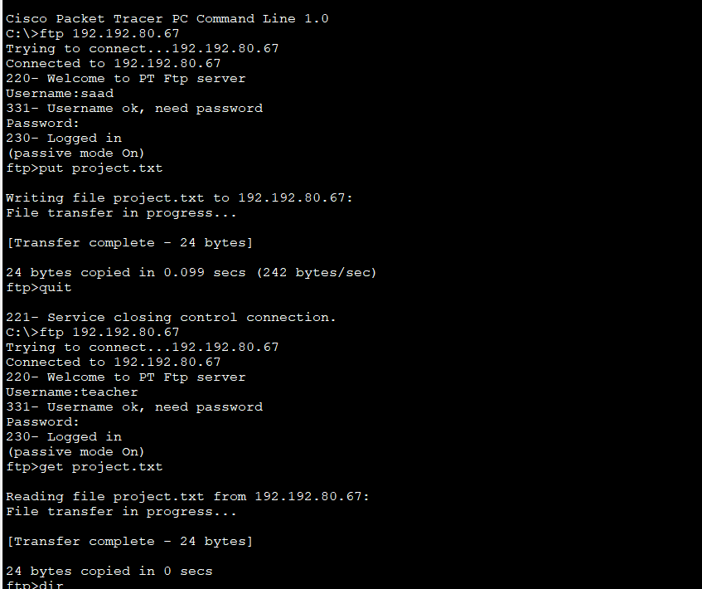

Step 3: see the file in the teacher’s directory:
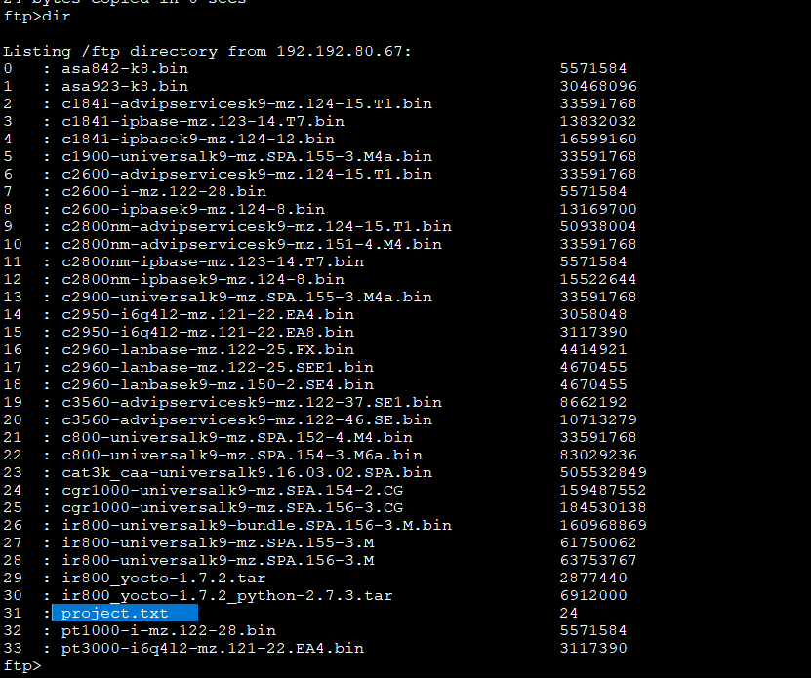
9-Wireless:
